Healthiness or calories? Side biases in food perception and preference
Valerio Manippa¹, Felice Giuliani^{1,2}, Alfredo Brancucci¹
1= Department of Psychological, Health and Territorial Sciences, University “G. d’Annunzio” of Chieti-Pescara
2= Laboratory of Behavioral Economics, Human Centered Design and Healthcare, University “G. d’ Annunzio” of Chieti-Pescara

Correspondence concerning this article should be addressed to Valerio Manippa (ORCiD: 0000-0003-3892-5212), Department of Psychological, Health and Territorial Sciences, University “G. d’ Annunzio” of Chieti-Pescara, 66100 Chieti. Tel: +39 3279834823; E-mail: valerio.manippa@unich.it

Abstract
The visual perception of a product and the ability to categorize it play a central role in food choice. People’s opinion of the healthiness and caloric content of a food is influenced substantially by its appearance. Despite that, few studies have analyzed i) which one of the two dimensions of caloric content and healthiness is preferred to categorize food, ii) if these dimensions are mapped on the individuals’ horizontal space, and iii) if such biases could influence food preferences. Therefore, through 4 experiments, we investigated which dimension, healthiness or caloric content, is more often used to categorize foods. We also evaluated whether a healthiness/caloric content side bias could be able to influence food preferences. We found that foods were mainly categorized as “Healthy” or “High-calorie” and the latter label was used more often when presented on the right of a foodstuff. Also, foods were categorized as healthier when the “Healthy” label was anchored to the left and the “Unhealthy” one to the right side of a visual analogue scale. Then, we found a more positive evaluation of transformed food when the key assigned to the “Pleasant” choice was on the right compared to the left. Lastly, we found that when presented on the left side, low-calorie was preferred compared to high-calorie food. Our findings shed light on both the fields of food categorization and side biases in food perception and preferences, suggesting the possibility to use these biases to promote a healthy diet and emphasizing the importance of considering this potential confounder in experimental setups.
Keywords: food perception; side biases; healthiness; caloric content; food preference; mental number line

Introduction
Food is essential to life, and the way in which we discriminate between different kinds of food has a central role in our survival (Foroni & Rumiati, 2016). Particularly, the visual perception of a product and the ability to categorize it play a key role in food choice (Eertmans, Baeyens, & Van Den Bergh, 2001). Aside from liking and edibility of food, researchers are focusing mainly on calorie content and healthiness perception of food, two features strongly involved in feeding behavior (e.g. Manippa, van der Laan, Brancucci & Smeets, 2019a; Engell, Bordi, Banja, Lamber & Rolls, 1998) and negatively associated with each other (i.e. high-calorie products are perceived as unhealthy and vice-versa; e.g. Carels, Harper & Conrad, 2006; Prada, Garrido, & Rodrigues, 2017a). Although there is not an objective way to define a food as low-calorie/high-calorie or as healthy/unhealthy, people are able make assumptions about these properties from the appearance of a food (e.g. Charbonnier, van Meer, van der Laan, Viergever, & Smeets, 2016; Toepel, Knebel, Hudry, le Coutre, & Murray, 2009). In turn, food calorie content and healthiness perception are linked to the level of transformation of a food. This is a more objective way to categorize foods (e.g. Foroni, Pergola, Argiris & Rumiati, 2013; Manippa, Padulo, & Brancucci, 2018): natural foods are products not directly modified by humans, such as raw fruit or vegetables, and are perceived as healthier and usually less caloric, whereas transformed foods are modified by human activity and are usually more caloric and perceived as less healthy (e.g. Arvola et al., 2008; Padulo et al., 2018, Prada et al., 2017a).
Despite the different scales (e.g. visual analogue scale, Likert scale) used to assess food healthiness and caloric content perception, few studies have analyzed i) which one of these two dimensions is preferred to categorize food, and ii) if these dimensions are also mapped on the individuals’ horizontal space. Recently, Romero and Biswas (2016) proposed and demonstrated, through a series of studies, that healthy products are mentally represented in the individuals’ left space, and thus they are preferably chosen (and consumed) when placed on the left rather than when placed on the right of the consumer. The authors motivated their findings based on the research related to spatial representation of magnitude in which individuals tend to mentally map increasing magnitudes from left to right (Dehaene, 2011). Actually, healthy items are perceived to be less heavy (Deng & Kahn 2009), lower in calories (Chandon & Wansink, 2007), less filling (O'Dougherty et al., 2006), and less tasty (Raghunathan, Naylor, & Hoyer, 2006) than unhealthy items. In addition to magnitude representation in space, they interpret their findings also in light of the body specificity hypothesis (Casasanto & Chrysikou, 2011), due to the higher desirability of high-calorie foods. This theory proposes that individuals represent pleasant products on their dominant side and unpleasant products on their non-dominant side (e.g. Casasanto, 2009; Brookshire & Casasanto, 2012; Giuliani, D’Anselmo, Brancucci, Tommasi & Pietroni, 2017; Giuliani, Manippa, Brancucci, Tommasi, & Pietroni, 2018) and since most human beings are right-handed, the pleasant side is mainly represented on the right.
However, Romero and Biswas (2016) have not fully explored the processes underlying their findings. According to their results, the healthiness mental representation would decrease from left to right, contrary to the generalized system of magnitude representation increasing from left to right (Bueti & Walsh 2009; Lourenco & Longo 2010; Walsh 2003). Hence, they suggest that other features (e.g. the lower caloric content and heaviness) of healthy food may be responsible for the observed side bias. Between the two hypothesized features, the caloric content is the more interesting, since unlike healthiness or other features such as tastiness, fullness and desirability, it is an objective numerical magnitude which the human brain seems to be naturally able to detect (e.g. Frank et al., 2010; Killgore et al., 2003; Toepel et al., 2009) due to its evolutionary importance. Therefore it is possible that caloric content is a food feature mentally mapped on the horizontal space in line with the principle of the Mental Number Line (MNL, e.g. Restle, 1970; Dehaene, Bossini, & Giraux, 1993; Bächtold, Baumuller, & Brugger, 1998; Wood, Willmes, Nuerk, & Fischer, 2008). This theory states that our mental representation of numbers resembles a number line increasing from left (smaller numbers) to right (larger numbers), leading to the SNARC effect (Spatial Numerical Association of Response Codes; Dehaene et al. 1993). Behaviorally, responses given with the left hand are facilitated when the stimulus is associated to small numbers, on the contrary, responses given with the right hand are facilitated when the stimulus is associated to large numbers. This spatial-magnitude association principle seems to be applicable to other magnitudes as well (SNARC-Like effect; see for instance Ren, Nicholls, Ma & Chen, 2011; Sellaro, Treccani, Job & Cubelli, 2015). Thus, this theoretical framework would be suitable to assess whether the results found by Romero and Biswas can be explained in terms of a horizontal mental mapping for caloric content that resembles the MNL.
Similarly, the influence of food desirability on side biases has not been well investigated. Indeed, Romero and Biswas (2013) proposed that the left bias for healthy foods could be determined by their lower desirability compared with the unhealthy items (represented on the right side), in line with the body specificity hypothesis (BSH). Particularly, Casasanto (2009) has shown that the concept of “good” seems to be represented on the right (dominant) side whereas the concept of “bad” on the left (non-dominant) in right-handed participants. Furthermore, Brookshire and Casasanto (2012) postulated the “Sword and Shield Hypothesis” (SSH) affirming that the hemispheric asymmetry of affective motivation depends on the laterality of motor control for the dominant hand. Hence for the right-handers the right is the ‘‘sword/approaching” hand other than the “good” side, whereas the left corresponds to the “shield/avoidance” hand other than the “bad” side. Nevertheless, Romero and Biswas (2013) have not assessed the valence of their stimuli, whereas it is not possible to state a priori that healthy foods are undesirable (e.g. Blechert, Meule, Busch & Ohla, 2014; Prada, Rodrigues, Garrido & Lopes, 2017b).
Another issue regards the concept of “desirability” in eating behavior: although some authors refer to desirability, liking and valence interchangeably, the desirability of a food is different form its liking and such concepts are neurobiologically dissociable. ‘Liking’ refers to palatability, namely the pleasure derived from eating a given food, depending on food sensory properties, physiological state and associative history of the individual. On the other hand, ‘wanting’ refers to the current disposition to eat a targeted food, namely the appetite for a specific product in a specific moment (Berridge, 2004). Finlayson, King and Blundell (2007) developed also a behavioral task to dissociate such concepts: the Leeds Food Preference Questionnaire (LFPQ) is a computer-based paradigm in which the liking is assessed through a rating task, and the wanting/desire to eat is assessed through a forced-choice task, pairing equally liked foods with different macronutrients/caloric content. This method has been applied in many studies, demonstrating the strong influence of interindividual (e.g. gender) and physiological (e.g. satiety) variables (e.g. Manippa, Padulo, van der Laan & Brancucci, 2017; Finlayson et al., 2007) on food picture desirability. Thus, the use of liking balanced foods would allow us to disentangle the interplay of BSH on food healthiness laterality bias.
Hence, to fill the aforementioned gaps, we carried out 4 experiments. Experiments 1 and 2 explicitly investigated which of the two features, healthiness or calories, is more often used to categorize food pictures, and whether such categorizations are influenced by side biases. Then we carried out a further experiment to investigate whether the laterality effect may be replicated using a more implicit judgment task. Finally, we tested whether those effects are able to influence food desire (experiment 4). Taken together our experiments should i) contribute to understanding cognitive processes related to food perception and categorization, ii) expand the current literature on the horizontal mapping of food perception and preference, and iii) shed light on the possible underlying reasons of such horizontal mapping.

Experiment 1. The influence of labels position on food categorization.
Our experiment 1 is a variant of the study 2a of Romero and Biswas (2016) in which they employed a conceptual classification task (Casasanto, 2009). In contrast to that study, our task was not only aimed to find a laterality effect in the classification but also to investigate how foods were classified.
Thus, we explore whether people have a preferential way to categorize foods based on caloric content (i.e. high-calorie and low-calorie) or healthiness (i.e. healthy and unhealthy). If a preference exists, the most used labels will belong to the same dimension (e.g. high-calorie and low-calorie). On the contrary, if a preference does not exist, the two most used labels will belong to different dimensions (e.g. high-calorie and healthy). Also, we analyze if a laterality bias exists for the two most used labels, regardless of whether they belong to the same or different dimension.
Participants and stimuli
Sixty-two (32 females) normal-weight (M Body Mass Index = 23.1, SD = 3.6) Italian young-adults (M age 22.5, SD = 8) have been recruited by telephone. Eight of them were left-handed (1 female) and no-one declared any food restrictions (vegetarianism, religious, following special diets etc.), intolerances or allergies.
We have selected 72 edible food images from the FRIDa database (Foroni et al., 2013). Thirty-six were natural foods (NaFd) and 36 were transformed foods (TrFd) with comparable mean valence, familiarity and discriminability scores but with different mean arousal and calories scores (perceived and real) higher for TrFds compared with NaFds (see Table 1). The pictures’ size was 300 x 300 pixels.

 | Natural foods |  | Transformed foods
Rating | M | SD | M | SD | p
Valence | 70.45 | 4.15 | 71.06 | 3.44 | .611
Familiarity | 58.11 | 14.60 | 56.56 | 9.71 | .766
Discriminability | 9.51 | 6.69 | 10.96 | 8.27 | .499
Arousal | 34.15 | 8.19 | 50.81 | 8.04 | < .001
Perceived Calories | 20.15 | 12.53 | 72.76 | 13.53 | < .001
Real Calories (Kcal/100g) | 60.17 | 80.13 | 351.53 | 128.77 | < .001

Table 1. Mean and standard deviation of different characteristics of natural and transformed food items selected for experiments 1 and 2 (Foroni et al, 2013).

Procedure and Data Analysis
Participants were invited to sit about 50 cm from the computer screen (1280 x 768 pixels, 15.4 inch) and were given all the necessary information to perform the experiment correctly. After entering their personal and anthropometric data, each participant read the instructions presented on the computer screen. They were instructed to categorize the target foods (placed on the center of the screen) using only one of the four labels proposed (placed at the four corners of the screen). We advised participants to read carefully the labels placed at the corners since their arrangement could change for each food.
Each experimental trial started with a fixation cross (1.5 s) followed by the response screen with a food picture placed in the center and the four labels displayed in the 4 corners of the screen (see Figure 1). The labels indicated the following words (written in Italian): "High-calorie" (“Ipercalorico”), "Low-calorie" (“Ipocalorico”), "Healthy" (“Salubre”) and "Unhealthy" (“Insalubre”). Each label was followed by a letter in brackets, indicating the key to press (“E” for the upper left, “C” for the lower left, “O” for the upper right and “M” for the lower right) to select the corresponding answer (e.g. "High-calorie (E)" in the case of high-calorie label placed in the upper-left corner). The response screen was shown until participants pressed a response key. For each item, the position of the labels and the order of presentation of the foods were randomized. The average time to complete the experiment was approximately 15 minutes.
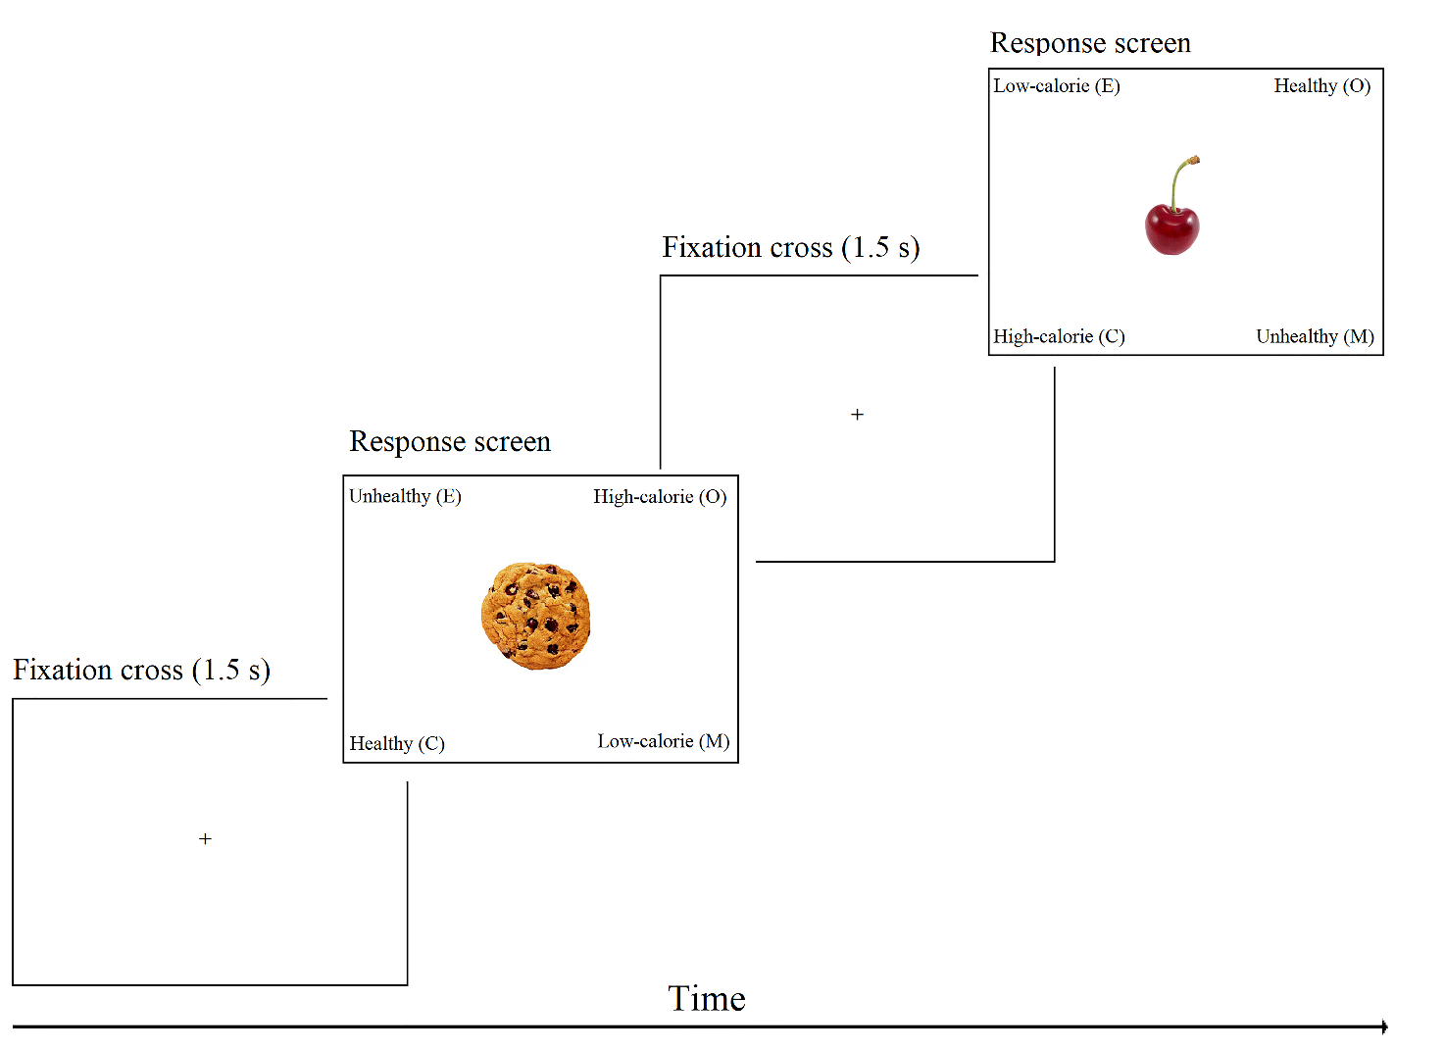
Figure 1. Experiment 1: example of experimental trials.

Data analysis was conducted using IBM SPSS Statistics version 20 (IBM Corp). The dependent variable was the frequency of use (in percentage) of the 4 labels for each participant.
First, we carried-out a series of Chi-square tests in order to evaluate if the distribution of the frequency of use of healthiness-related labels (HE, UH) and calorie-related labels (LC, HC) differed from chance. Then, we compared by another series of Chi-square tests if the distribution of the frequency of use of the 4 labels (i.e. HE, UH, HC, LC) was significantly different from chance. Thus, we assessed with 2 further Chi-square tests if the distribution of the frequency of use of the 2 most used labels was influenced by their horizontal position (left vs. right).
Finally, splitting food items in NaFd and TrFd, we examined through a Chi-square test if, in line with the current literature, NaFds were categorized mainly as HE and LC, whereas TrFd as UH and HC.
Results
We found that the distribution of frequency in the use of healthiness-related labels and calories-related labels differed significantly from a chance distribution (χ 2₍₁₎ = 105.42, p < .001; see Fig. 2a) with a prevalent use of healthiness-related labels (57.7 %) compared to calories-related ones (42.3 %). Significant differences between the frequency use of the 4 labels and the chance probability were observed (χ 2₍₃₎ = 1128.42, p < .001). The most used labels were HE (44.4%) and HC (27.8%). Particularly, participants used more often the label HE to categorize foods, compared with UH (χ 2 ₍₁₎ = 749.25, p < .001), HC (χ 2=169.85, df=1, p < .001) and LC labels (χ 2 ₍₁₎ = 677.91, p < .001). Also, participants used more often the label HC compared with LC (χ 2 ₍₁₎ = 187.41, p < .001) and UH labels (χ 2 ₍₁₎ = 229.54, p < .001). Finally, there was no difference (χ 2 ₍₁₎ = 2.35, p = .125) in the frequency of use of the labels LC (14.5%) and UH (13.3%). All the comparisons are reported in Figure 2b.
Regarding the two most used labels (HE and HC), there was no differences in the use of HE label depending on the side of presentation (χ 2 ₍₁₎ = 1.07, p = .301). The side of presentation, instead, influenced the use of HC (χ 2 ₍₁₎ = 5.41, p = .020; see Fig. 2c) selected more often when presented on the right (53.3%) compared with the left side (46.7%) of the categorized food.
Finally (see Table 2) we confirmed a preference in the use of HE and LC labels for NaFd categorization (χ 2₍₃₎ = 2710.49, p < .001), whereas TrFds were categorized mainly as HC and UH (χ 2₍₃₎ = 846.00, p < .001).

Figure 2. Significant interaction and post-hoc comparisons between the a) frequency use of healthiness (“Healthy” + “Unhealthy”) vs. calories (“Low-calorie” + “High-calorie”) labels; b) frequency use of all the labels; c) frequency use of “High-calorie” label when displayed on the left vs. right side of the screen. Dashed line indicates the frequencies predicted by chance. Data are reported as percentages.

 | Frequency of use (Label)
 | Unhealthy |  | Healthy |  | Low-calorie |  | High-calorie
Food | % | N° | % | N° | % | N° | % | N° | p
Natural foods | 4.3 | 97 | 71.6 | 1599 | 19 | 423 | 5.1 | 113 | < .001
Transformed foods | 22.2 | 496 | 17.2 | 338 | 10 | 224 | 50.6 | 1129 | < .001

Table 2. Frequency of use in percentage (%) and number of observations (N°) of the different labels for natural and transformed food categorization.

Discussion
Our results demonstrate the existence of a preferential way to categorize foods. In general individuals seem to categorize food mainly on its healthiness more than on its caloric content. HE was the most used label (mainly for NaFds categorization), followed by HC label (mainly for TrFds categorization). Both UH and LC labels were used less often. Finally, HC label was used more often when shown on the right side compared to the left side. On the contrary, no bias has been reported for HE label, contrary to the Romero and Biswas’s hypothesis (2016) assuming a left side bias for HE products.
This pattern suggests the existence of a side bias for calorie evaluation. Caloric content is an objective magnitude automatically detected by humans (e.g. Toepel et al., 2009), thus it can be theoretically represented along the MNL. This magnitude-based mental representation could be responsible for the cognitive mapping of lower calorie content to the left (smaller magnitude) and higher calorie content to the right (larger magnitude). This mechanism might explain the bias found in Romero and Biswas (2016) (healthy-left/unhealthy-right) with healthiness being inversely related to caloric content i.e. healthy food means also low-calorie food (left mapping), whereas unhealthy food means also high-calorie food (right mapping). The second experiment was carried out to better understand this bias.

Experiment 2. The influence of labels position on food calorie and healthiness perception.
Our experiment 1 kept in doubt the existence of a healthy-left/unhealthy-right bias. In fact, Romero and Biswas (2016) did not specify whether the side bias was linked to calorie or healthiness perception. As stated above, the HE-left/UH-right bias can be considered the counterpart of the LC-left/HC-right bias lead by the existence of an horizontal mapping, increasing from left to right, (e.g. Walsh, 2003) for calorie estimation, that should follow the principles of the MNL.
In order to test this hypothesis, in experiment 2 we investigated if the healthiness and calorie perception of food pictures would be influenced by the labels arrangement on the corresponding Visual Analogue Scale (VAS). We supposed that individuals evaluate foods as healthier when the label HE is anchored to the left end and the label UH is anchored to the right end of the VAS (Congruent arrangement; Cong) compared with the opposite labels arrangement (Incongruent arrangement; InCong), in line with Romero & Biswas hypothesis (2016). At the same time, if a caloric MNL exists (Wood et al., 2008), foods would be evaluated as more caloric when the label HC is placed on the right and the label LC on the left end (Cong) of the respective VAS and less caloric when the labels are inverted (InCon). Such effects could occur for both caloric and healthiness evaluation or independently, allowing us to understand whether the side bias is specific or not.
Participants and Stimuli
A new sample of fifty (37 females) normal-weight (M Body Mass Index = 22.9, SD = 1.9) Italian young-adult (M age 24.5, SD = 10.3) participants were recruited by telephone. Four of them were left-handed (4 females) and no-one declared any food restrictions (vegetarianism, religious, following special diets etc.), intolerances or allergies.
The stimuli were the same of experiment 1, namely 36 NaFds and 36 TrFds taken from the FRIDa database (Foroni et al., 2013).
Procedure and Data Analysis
Participants were invited to sit about 50 cm from the computer screen (1280 x 768 pixels, 15.4 inch) and were given all the necessary information to perform the experiment correctly. After entering their personal and anthropometric data, each participant read aloud the instructions presented on the computer screen. Their task was to evaluate the healthiness and calorie content of the target foods dragging and dropping, using the computer mouse, the cursor placed at the center of the respective VASs. We informed participants to read carefully the labels (written in Italian) anchored to each end of the VAS (HE/UH for healthiness, HC/LC for calorie content), since they could be arranged differently for each trial.
Thus, each experimental trial (Figure 3) started with a fixation cross (1.5 s) followed by the presentation of a food picture placed in the center of the screen for 3 seconds. Following the food, a first VAS appeared with the cursor placed in the middle. Once answered, a second VAS appeared again with the cursor placed in the middle. The order of presentation of the two VASs (i.e. healthiness and calorie content) was randomized for each item as well as the side in which the labels were anchored. The average time to complete the experiment was approximately 15 minutes.
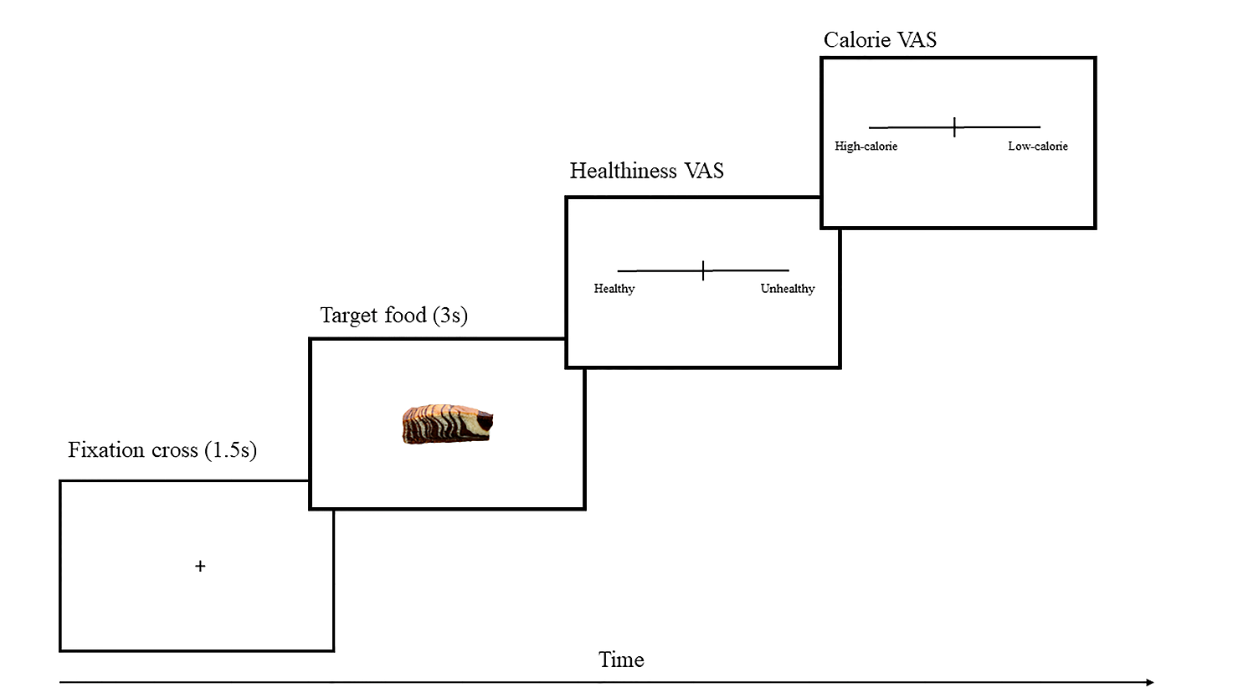
Figure 3. Experiment 2: example of experimental trial.

Data analysis was conducted using Statistica 8.0 (StatSoft, Tulsa, Oklahoma). The dependent variable was the mean VAS score (ranging from -50 to +50) assigned from each participant to food pictures. The point 0, corresponding to the center of the VAS in which the cursor is placed, represented a neutral response (i.e. neither low-calorie nor high-calorie and neither healthy nor unhealthy). We assumed negative values (i.e. from -1 to -50) to be scored when participants moved the cursor toward the UH and LC labels, whereas we assumed positive values (i.e. from +1 to +50) to be scored when participants moved the cursor toward the HE and HC labels regardless of the labels side. No participants showed outlier values (± 3 SD).
Thus, for each variable (Caloric and Healthiness scores), a 2 x 2 repeated measures analysis of variance (ANOVA) was performed using label arrangement (Cong, InCong) and food category (NaFd, TrFd) as within factors. The significance threshold was set at p < .05 and Duncan post-hoc analyses were carried out for significant results.
Results
The ANOVA carried out on healthiness scores showed a main effect of labels arrangement (F_{1, 49} = 4.18, p= .046), with a healthier evaluation of foods in the Cong (M= +11.51) compared with the InCong (M= +9.76), a main effect of food category (F_{1, 49} = 636.86, p< .001), with NaFd evaluated as healthier (M= +33.93) than TrFd (M= -12.68), and a significant interaction between food category and labels arrangement (F_{1, 49} = 4.47, p= .039; see Fig. 4a). Particularly Duncan’s post-hoc analysis showed that NaFds were evaluated as healthier compared with TrFds (p< .001) for both the arrangement conditions. Also, TrFd was evaluated less unhealthy in the Cong compared with the InCong arrangement (p= .010).
The ANOVA carried out on calorie scores showed a main effect of food category (F_{1, 49} =340.63, p< .001; see Fig. 4b) with NaFd evaluated less caloric (M= -16.68) compared with TrFd (M= +23.27) and no other significant effects.
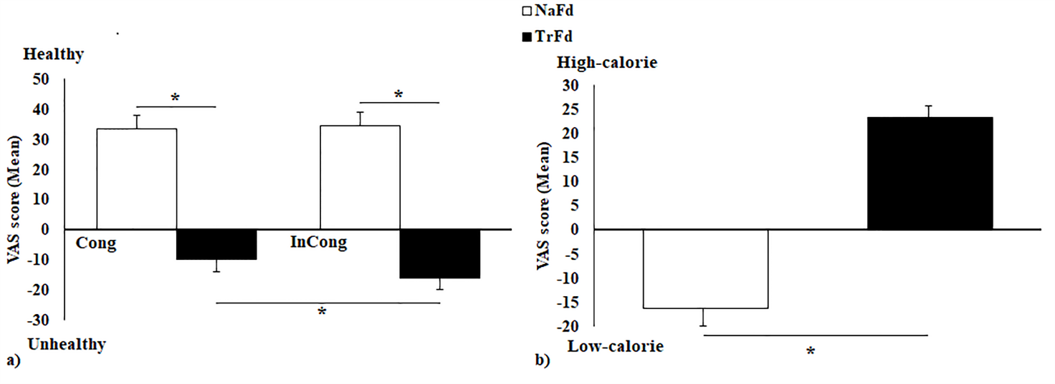
Figure 4. Significant interaction and comparisons between the: a) healthiness evaluation of natural and transformed foods in the congruent and incongruent conditions; b) caloric evaluation of natural and transformed foods. Data are reported as mean + standard error of the mean.

Discussion
In the second experiment we tested the existence of a magnitude based (MNL) mechanism in food healthiness/calorie content evaluation, manipulating the side in which the labels were anchored on the respective VASs. Particularly we found a significant effect only for healthiness perception, with foods evaluated healthier when HE was anchored to the left and UH on the right of the VAS, congruently with Romero and Biswas hypothesis (2016). This effect was largely determined by TrFds, perceived less unhealthy when HE was anchored to the left and UH to the right end of the VAS (Cong arrangement) compared with the InCong arrangement. Regarding calories, the existence of a horizontal mapping resembling the MNL has not been confirmed by this second experiment.
The differences in task request between the first two experiments could have played a role in the contradictory results, suggesting that more implicit tasks should be used and additional hypotheses, such as the BSH, should be tested, in order to deepen and clarify the causes of the healthy-left/unhealthy-right bias.

Experiment 3. The influence of response key side on food pleasantness recognition.
Both experiments 1 and 2 showed that the laterality biases involved mainly TrFds classification/perception. Transformed and natural food pictures used in our experiments had comparable valence. Thus, in experiment 3 we investigate if pleasantness evaluation of food items is influenced by the position of the response keys. Particularly, we predict that unpleasant rotten food (UpFd) and edible pleasant food (PlFd) would be more accurately/rapidly classified respectively as “Unpleasant” and “Pleasant” when the key assigned is congruent with the BSH/SSH (i.e. “Unpleasant” response assigned to the left key, “Pleasant” response assigned to the right key) compared with the converse arrangement. Moreover, we predict that such a paradigm would also influence the evaluation of natural and transformed foods (subcategories of PlFd). Particularly, NaFd would be classified more accurately/rapidly when the “Pleasant” response is assigned to the left key with this side associated with healthy/low-calorie foods. On the contrary, TrFd would be more accurately/rapidly classified when the “Pleasant” response is assigned to the right key, with the right side preferentially associated with unhealthy/high-calorie items.
Participants and Stimuli
A new sample of ninety (67 females) normal-weight (M Body Mass Index = 22.0, SD = 2.8) Italian young-adults (M age 22.9, SD = 2.8) has been recruited by telephone. Eight of them were left-handed (4 females) and no-one declared any food restrictions (vegetarianism, religious, following special diets etc.), intolerances and allergies. They were divided in 2 groups (N = 45) having comparable features (BMI, age, sex, handedness).
We selected 72 food images from the FRIDa database (Foroni et al., 2013) divided according to their opposite valence in 36 pleasant edible foods (PlFd) with high positive valence and 36 unpleasant rotten foods (UpFd) with high negative valence. The 36 PlFd pictures were additionally subdivided into 18 NaFds (non-processed) and 18 TrFds (processed, e.g. cooked). They did not differ significantly in mean valence and familiarity, but only in their calorie content (real and perceived) and mean arousal attribution (TrFd > NaFd). Also, NaFd are well-known to be perceived as healthier compared to TrFd (e.g. Monteiro, 2009; Prada et al., 2017a). Food features are presented in Table 3.

 | PlFd | UpFd |  | NaFd | TraFd
Rating | M (SD) | M (SD) | p | M (SD) | M (SD) | p
Valence | 78.9 (10.8) | 5.2 (2.3) | < .001 | 78.5 (12.3) | 79.2 (9.3) | .822
Familiarity | 66.6 (13.2) | 11.21 (2.3) | <. 001 | 68.1 (13.9) | 63.2 (12.5) | .459
Discriminability-Ambiguity | 6.1 (5.6) | 47.6 (22.3) | < .001 | 5.5 (4.5) | 6.6 (6.8) | .607
Arousal | 49.6 (8.7) | 25.9 (8.3) | <. 001 | 40.9 (9.2) | 58.4 (7.6) | <. 001
Perceived calories | 48.8 (14.4) | 22.4 (14.6) | < .001 | 19.5 (14.8) | 78.2 (14.1) | <. 001
Real Calories (Kcal/100g) | 214.5 (184) | 89 (100) | <. 001 | 66 (99) | 363 (115) | <. 001

Table 3. Mean and standard deviation of different characteristics assessed by Foroni and coworkers (Foroni et al, 2013) of pleasant, unpleasant, natural and transformed food items selected for experiment 3.

Procedure and Data Analysis
Participants were invited to sit about 50 cm from the computer screen (1280 x 768 pixels, 15.4 inch) and were given all the necessary information to perform the experiment correctly. After entering their personal and anthropometric data, each participant read aloud the instructions presented on the computer screen. They were instructed to judge the target food as “Pleasant” or “Unpleasant” by a key press. Particularly, the 2 groups were assigned to two different conditions: in the Pleasant-right condition (Pl-Right) the “A” key (to be pressed using the left index finger) was associated with the answer “Unpleasant” and the “L” key (to be pressed using the right index finger) was associated with the answer “Pleasant” and vice-versa for the group assigned to the Pleasant-left condition (Pl-Left).
Thus, each experimental trial started with a fixation cross (ranging from 2 to 4 s) followed by the presentation of a food picture placed in the center of the screen. From the picture onset, participants had 1.5 seconds to judge it, by pressing one of two different keys (“A” and “L”) on a computer keyboard, therefore we encouraged participants to respond as fast and accurately as possible. The average time to complete the experiment was approximately 10 minutes.
Data analysis was conducted using Statistica 8.0 (StatSoft, Tulsa, Oklahoma). Dependent variables were the percentage of correct responses (CRs) for each participant (i.e. pleasant judgment for pleasant food and unpleasant judgment for unpleasant food), and reaction times (RTs) calculated as the median reaction time of the CRs for each participant. Concerning CR percentage, the variable was not normally distributed (Kolmogorov-Smirnov test) and thus we applied rank transformation (John, Van Lishout, Gusareva, & Van Steen, 2013) fractional as percentage. Participants showing median RTs and CRs rank outlier values (criterion: ± 3SD) were excluded (N=3).
For each variable (CR and RT) we carried out a 2 x 2 repeated measures analysis of variance (ANOVA) using target food (PlFd, UpFd) as within factor and the group/key arrangement (Pl-Right, Pl-Left) as between factor. A second ANOVA was carried out using PlFd subcategories (NaFd, TrFd) as within factor and the group/key arrangement (Pl-Right, Pl-Left) as between factor. The significance threshold was set at p=.05 and Duncan post-hoc analyses were carried out for significant ANOVA effects.
Results
Considering the CRs, the 2 x 2 ANOVA carried out using as factors the target food (PlFd, UpFd) and the group/key arrangement (Pl-Left, Pl-Right) showed a significant main effect of group/key arrangement (F_{1, 85} = 6.622, p= .012; see Fig. 5a) due to higher CRs for the Pl-Right compared with the Pl-Left arrangement, and no other significant effect. Regarding the RTs a significant interaction was found between the target food (PlFd, UpFd) and group/key arrangement (F_{1, 85} = 4.669, p= .033) and no other significant effect. Nevertheless, Duncan post-hoc analysis did not show any significant effect.
Considering the CRs, the 2 x 2 ANOVA carried out using as factors PlFd subcategory (NaFd, TrFd) and the group/key arrangement (Pl-Left, Pl-Right) showed a significant interaction (F_{1, 85} =3.895, p = .050; see Fig. 5b) and no other significant effect. Duncan post-hoc showed higher CRs for TrFd in the Pl-Right compared with Pl-Left key arrangement (p = .047). Considering the RTs, the 2 x 2 ANOVA showed a significant main effect of PlFd subcategory (F_{1,85}=6.032, p= .016), with NaFd judged faster than TrFd, and a significant interaction (F_{1, 85} =5.555, p= .021; see Fig. 5c). Particularly, Ducans’ post-hoc showed a faster evaluation for NaFd compared with TrFd in the Pl-Right key arrangement (p = .002).
All significant comparisons are reported in Figure 5.
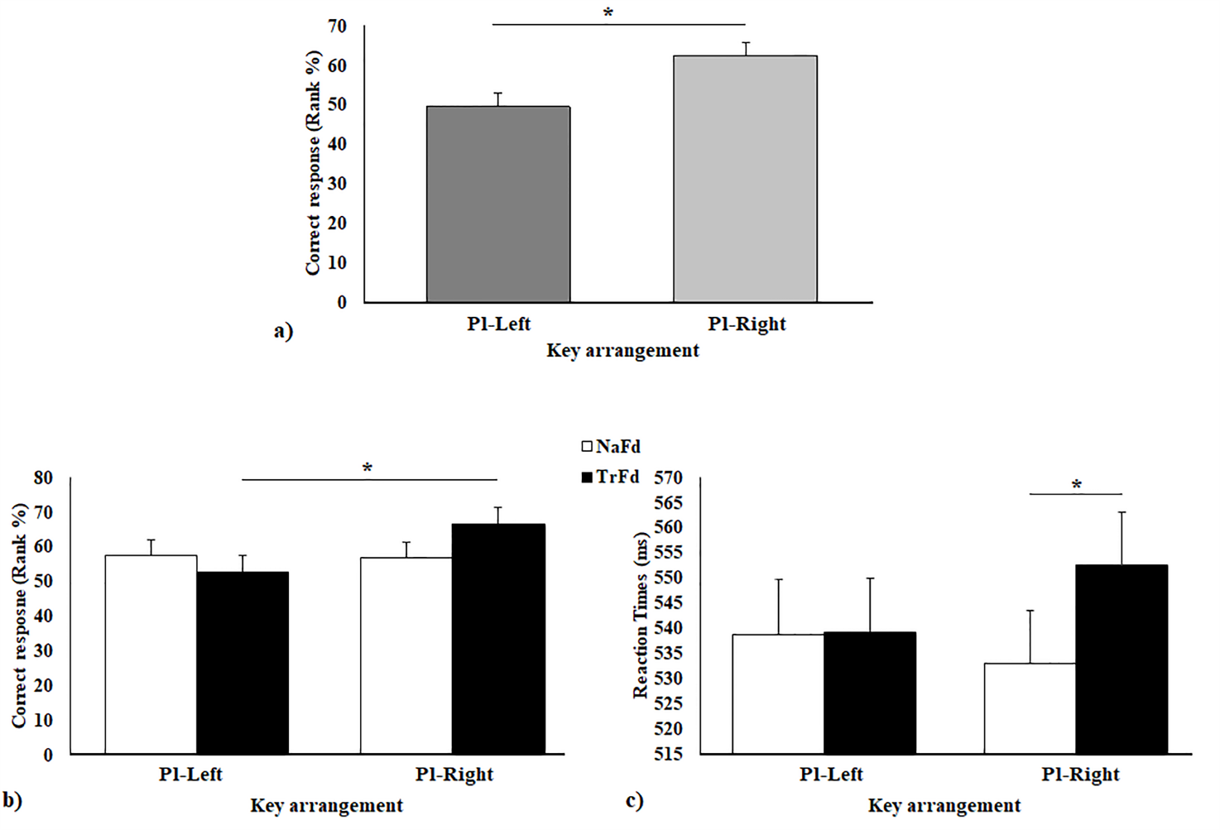
Figure 5. Significant interaction and comparisons between the: a) correct responses (in rank %) for the group assigned to the pleasant-left key arrangement (“Pleasant” key on the left; “Unpleasant” key on the right) compared to the group assigned to the pleasant-right key arrangement (“Unpleasant” key on the left; “Pleasant” key on the right) and; b) correct responses (in rank %) and c) reaction times (in ms) for the categorization of natural and transformed food for the group assigned to pleasant-left key arrangement vs. the group assigned to the pleasant-right key arrangement. Data are reported as mean + standard error of the mean.
Discussion
In line with the BSH/SSH (Casasanto, 2014), the group in the Cong condition (“Unpleasant” key pressed by the left and “Pleasant” pressed by the right hand) judged more correctly the food valence. Regarding the PlFd subcategories the results were interesting: particularly, TrFd was more likely to be evaluated as “Pleasant” when the key was placed on the right, compared with when the key was placed on the left. Also, when the “Pleasant” key was placed on the right, NaFd was evaluated more rapidly compared with TrFd. The first finding is congruent with the healthy-left/unhealthy-right hypothesis (Biswas & Romero, 2016) with TrFds usually perceived as unhealthy (e.g. Manippa et al., 2019a; Monteiro, 2009). Instead, regarding the faster response time to categorize NaFd when the “Pleasant” key was on the right, we suppose that the less visual complexity of NaFd pictures compared with TrFd ones has played a role (Foroni et al., 2013; Padulo et al., 2018; Prada et al., 2017a). Indeed, the right hand is controlled by the left hemisphere mainly involved in verbal stimuli analysis (and thus less efficient for complex pictures detection) compared with the right hemisphere controlling the left hand and specialized for visuospatial stimuli (d'Anselmo, Giuliani, Marzoli, Tommasi, & Brancucci, 2015; Umiltà, Bagnara & Simion, 1978).
In the 3 previous experiments, NaFd and TrFd pictures were extracted from the FRIDa database (Foroni et al., 2013) in order to have comparable mean valence, thus the found effects could not be influenced by its valence. Anyway, in order to definitively exclude the role of BSH (Casasanto, 2014) in our findings, and to test the effect of such laterality bias in food wanting, we implemented a last experiment using the LFPQ (Finlayson et al., 2007).

Experiment 4. The influence of display position on food preference.
The last aim of our study is to test whether all the healthy-left/unhealthy-right biases have an influence on the desire to eat specific products. On this matter, Romero and Biswas (2016) demonstrated that: i) the preference for the healthy products enhances when they are displayed to the left (vs. right) of the unhealthy products on a menu; ii) the preference for a healthy item (broccoli salad) was relatively higher when it was on the left (vs. right) of the unhealthy item (grilled cheese sandwich) and; iii) participants had a higher intake of the healthy beverage (low-calorie orange juice) when it was displayed to the left (vs. right) of the unhealthy beverage (high-calorie orange soda).
Despite these convincing results explained by Romero and Biswas through the BSH (which postulates the association between handedness and affective valence side biases), they have not assessed the subjective liking of the proposed products. Thus, in the last experiment, we used the LFPQ (Finlayson et al., 2007) in order to rule out the potential effect of foods liking. Hypothesizing that laterality bias is independent from the BSH, we would expect an increase in low-calorie/healthy products choice when the item is displayed on the left compared to the right (congruently with the left-side mental representation of healthy food). On the contrary, an increase in high-calorie/unhealthy products choice should occur when they are displayed on the right (congruently with the right-side mental representation of unhealthy food).
Participants and Stimuli
A new sample of forty-three (27 females) normal-weight (M Body Mass Index = 21.7, SD = 2.5) Italian young-adults (M age 21.9, SD = 2.8) were recruited by telephone. We asked participants to eat before the experiment in order to bring all participants to a comparable sated state. Two subjects were left-handed (1 female) and no-one declared any food restrictions (vegetarianism, religious, following special diets etc.), intolerances or allergies.
The task request (i.e. choose which food you want to eat now) led us to use another food database for this last experiment. Particularly, we used the Full4Health Image Collection (University Medical Center Utrecht; Charbonnier et al., 2016) where all the depicted items are ready-to-eat, differently from FRIDa (Foroni et al., 2013) in which not all the NaFds are so. Thus, we extracted 160 product pictures, 80 high-calorie foods (HcFd, M= 451 Kcal/100 g, SD= 99) and 80 low-calorie ones (LcFd, M= 71 Kcal/100 g, SD= 58).
Procedure and Data Analysis
Participants were invited to sit about 50 cm from the computer screen (1280 x 768 pixels, 15.4 inch) and were given all the necessary information to perform the experiment correctly. Particularly, for pairing equally liked products of different calories (HcFd and LcFd) we used the LFPQ (Finlayson et al., 2007) as already done in previous studies (e.g. Charbonnier et al., 2015; Manippa et al., 2017). First of all, each participant performed a rating task, in which he/she evaluated, by means of a 9-points Likert scale, the subjective liking, the calorie content, and the perceived healthiness of 160 products. As expected, HcFds were perceived unhealthier and more caloric compared to LcFds, whereas no differences were found in liking evaluation (rating data are shown in Table 4). Thus, based on the subjective rating of each participant, a Matlab script created a set food pairs made-up by a HcFd and a LcFd matched on liking (i.e. equal liking evaluation ± 1 on a 9-point Likert scale). Such a set was composed by a variable number of food pairs (depending by the individual rating) ranged from a minimum of 48 to a maximum of 78 pairs (M= 63.4). Afterwards, subjects have been involved in the forced choice task in which, after a fixation cross (1.5 s) a food pair was displayed, with a product on the left and a product on the right side of the reference point (in the center of the screen). Participants were instructed to choose, within 3 seconds, which product they wanted to eat at that moment by pressing “G” key for the left option and “L” key for the right option. The side of presentation of HcFd and LcFd was counterbalanced across trials. The whole procedure lasted about one hour.
Data analysis was conducted using IBM SPSS Statistics version 20 (IBM Corp). The dependent variable was the percentage of HcFd and LcFd chosen. We carried-out a series of Chi-square tests in order to assess if the frequency in which LcFd and HcFd was chosen when displayed on the left and on the right side differed significantly from that expected by chance.

 | High-calorie foods |  | Low-calorie foods
 | 451 ± 99 Kcal/100 g |  | 71 ± 58 Kcal/100 g
 | M | SD | M | SD | p
Liking | 6.02 | 1.23 | 6.34 | 1.18 | .107
Perceived Calories | 6.70 | 0.93 | 4.31 | 1.27 | < .001
Perceived Healthiness | 3.61 | 0.90 | 7.01 | 0.83 | < .001

Table 4. Mean and standard deviation of liking, perceived calories and healthiness assessed during the rating task for high-calorie and low-calorie foods.

Results
The frequency of choice of LcFd and HcFd was significantly influenced by the side of presentation (χ²₍₃₎ = 9.700, p = .021). LcFds shown on the left were the most chosen products (27.1 %), whereas HcFds shown on the left were the less frequently chosen products (23.0 %). Regarding the single comparisons, we found only one significant difference (χ²₍₁₎ = 9.026, p = .003; Fig. 6): when displayed on the left side, LcFds are more likely to be chosen compared to HcFds. The difference between LcFd choice when displayed on the left side and HcFd choice when displayed on the right side is almost significant (χ²₍₁₎ = 3.369, p = .055).
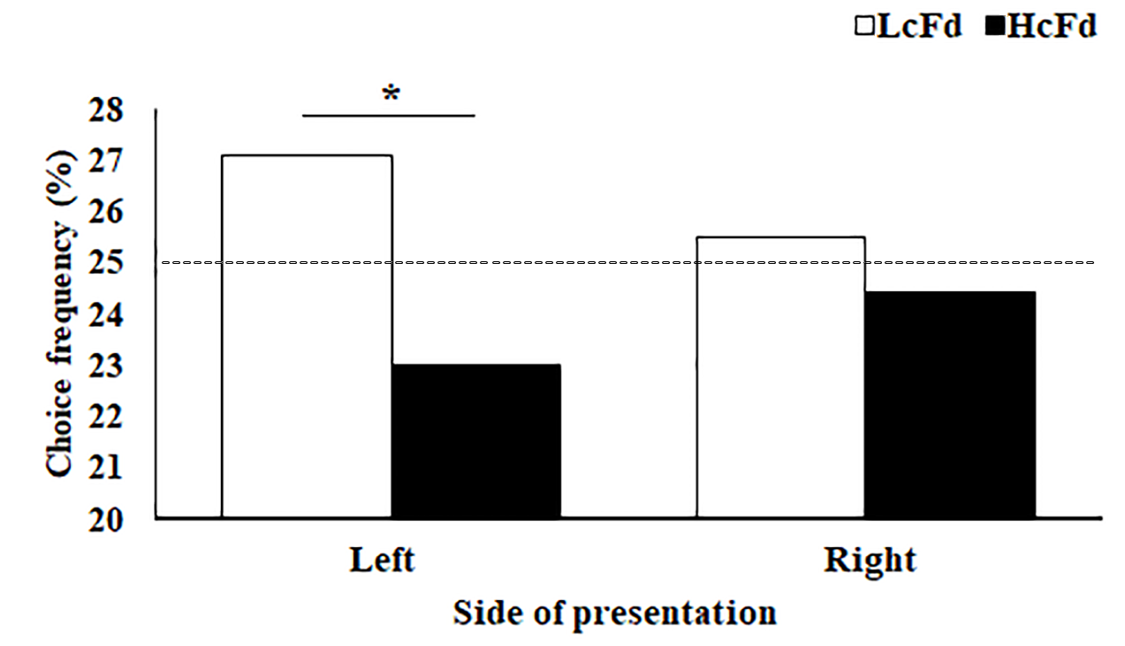
Figure 6. Significant interaction and comparisons between the choice frequency of high-calorie and low-calorie foods when displayed on the Left and on the Right of the fixation cross. Dashed line indicates the chance probability. Data are reported as percentages.

Discussion
The last experiment has been arranged using the LFPQ (Finlayson et al., 2007) in order to test the generalizability of Romero and Biswas. Particularly, we asked sated participants to choose which product they wanted to eat between a wide pair of high- vs. low-calorie products having comparable subjective liking.
Our data showed that LcFd is chosen more often compared with HcFd, when the former was displayed on the left side of the screen. These results corroborate the previous findings and the mental representation proposed by Romero & Biswas, (2016) reinforcing the hypothesis that such a representation was able to influence products desirability regardless of their liking. Also, the interplay between the BSH and the healthy/left-unhealthy/right seems to be ruled out with the products paired for subjective liking.
General discussion
In the first two experiments we tested if food categorization (in terms of healthiness and calories) can be affected by laterality biases. We demonstrated the existence of 2 different but congruent side biases: the enhanced use of the “High-calorie” label when placed on the right of the judged food and healthier evaluation of foodstuff when “Healthy” was anchored on the left side and ”Unhealthy” on the right side of the VAS. Then, through two further experiments, we tested if these side biases can affect food preferences. We found that participants are more likely to evaluate TrFds as “Pleasant” when such judgment was associated with a right-hand key. Similarly, individuals were more likely to choose healthy items when they were displayed on the left side.
Particularly, in experiment 1 we investigated if people categorize food mainly using healthiness or calorie features. Although our data suggested that individuals categorized food using mainly the healthiness dimension compared to the caloric one, it was evident that such an effect was led by the massive use of HE label followed by the HC one, whereas the use of LC and UH categories was rare. This means that people categorize food products using 2 labels belonging to different dimensions (i.e. HC and HE) rather than using labels belonging to the same dimension (i.e. HC and LC or HE and UH). The use of HE, strictly linked to NaFds classification, is probably due to the way we refer to and think about this type of food in everyday life: fruit and vegetables are often seen as something that boosts our health, containing vitamins and antioxidants, whereas the calorie content is maybe secondary in the categorization of this type of food. On the other hand, calorie content becomes more relevant for transformed food categorization, being products both able to satisfy our energy demands and strongly involved in weight concerns. Moreover, the affective valence and the thought evoked by the 4 labels used in the task could have played a role in such results. Among the 4 used labels, HE, the most used one, is also the most positive at a semantic level. Thus, although NaFds are both HE and LC, the term HE would be preferred due to the positive valence that such a term evokes, contrary to LC, a more neutral word (i.e. a low-calorie product is not healthy per-se). Similarly, the preference for the use of the term HC compared with UH for TrFds categorization could be determined by the less negative valence conveyed by the word HC compared to UH. Finally, the Lyons theory (1977) affirms that between a pair of opposite words the use of the semantically negative one is more limited than the positive one. This theory would explain the massive use of HE label compared with its negative counterpart UH (having the privative marker “Un-”).
Moreover, regarding laterality effects, in experiment 1 we found a higher frequency in the use of HC label when presented to the right compared to the left side of the target product. Obviously, this bias was linked to TrFds classification with HC label used to categorize almost exclusively this kind of products. On the other hand, no laterality bias was found for the use of HE label, leading us to doubt about the healthiness bias described by Romero and Biswas (2016). In their tasks it was not always possible to distinguish the concepts of HE/UH from the concepts of LC/HC. Therefore, calories being countable (Kcal), contrary to healthiness, the HE-left/UH-right bias could be a LC-left/HC-right bias determined by a hypothetical mental caloric line, increasing from left to right, resembling the MNL. Also, Deng & Kahn (2009) showed that the location of the product image on a package facade influences consumers’ perceptions of the visual heaviness of the product and evaluations of the package. Particularly, the “heavier” locations are on the bottom-right of the package. Such “Location effect” could have played a role in the enhanced use of HC label when displayed on the right. Nevertheless we point out that the terms LC and HC have a prefix , i.e. “Low-” and “High-”, implying a different magnitude per-se: such prefixes are missing in the words HE and UH, and this grammatical characteristic may have played a role in the laterality bias found here (higher magnitudes on the right). In both cases, LC label should be used more often when displayed on the left side, but the low frequency of use of this word made it impossible to test a possible laterality bias.
In experiment 2, by the means of VAS scales, we found that NaFds were perceived as healthier compared with TrFds (assessed as unhealthy), and healthiness estimation increased when the HE label was anchored to the left side of the VAS (and the UH to the right) compared to the opposite condition. On the other hand, we did not confirm the bias found in our first experiment: TrFds are generally perceived as more caloric than NaFds, and the side in which HC/LC labels were anchored did not influence the caloric perception. These differences can be task specific: while in experiment 1 a forced categorization between discrete categories was implemented, in experiment 2 we asked to evaluate these categories on a continuous scale. Particularly, since in both experiments the side biases were determined by TrFd, the difference must be related to the way in which this food has been categorized/evaluated. Considering the results found in the second experiment, we can reinterpret the bias found in experiment 1 as a semantic effect of the prevalent use of HC label, compared with the rare use of UH label, for TrFd categorization. With HC the opposite of UH, it is likely that in the first task we have boosted a semantic effect while in the second task we have observed the actual healthiness-related perceptual bias. We point out that, despite caloric content being countable and magnitude represented/labeled on a continuum from LC to HC, a side bias increasing from left to right (SNARC-Like effect) was not found. On the contrary, the effect found for the healthiness perception suggests that calories and healthiness are processed differently, and that the healthiness dimension is probably mapped on the horizontal space, as previously described by Romero and Biswas (2016). The MNL metaphor states that the magnitude of numbers is mentally represented as increasing from left to right (e.g. Kadosh et al. 2008), due to the western societies’ linguistic conventions (i.e. reading and writing). Considering our findings, we suggest that caloric content, which is a numerical magnitude, is not influenced by the MNL, whereas a horizontal mapping for healthiness (a non-numerical magnitude) seems to exist. However, this pattern of results could benefit from further clarification, hypothesizing the interplay between additional factors. For example, although our stimuli were valence-balanced, the relevant role of such a feature in laterality biases (e.g. BSH) have not been sufficiently taken into account in food judgment and choice tasks so far.
Thus, in the last 2 experiments, we explored side biases in a more implicit way. Particularly in experiment 3 we found a general confirmation of the BSH/SSH using a task in which participants had to judge rapidly if a target food was “Pleasant” or “Unpleasant” by a key press. In fact, congruently with Casasanto’s hypothesis (2014) the judgments were more correct (i.e. rotten food judged as “Unpleasant” and pleasant foods as “Pleasant”) when the “Unpleasant” (bad/avoidance) key was assigned to the left hand and the “Pleasant” (good/approach) to the right hand. No main effect of the key arrangement has been found for RTs. Then, exploring how the assigned response key influenced NaFd and TrFd evaluation, we found that TrFd were judged as pleasant more often when the “Pleasant” key was on the right side compared to when it was on the left side of the keyboard. Again, this was congruent with the attitude to associate unhealthy/high-calorie products as TrFds to the right side. Despite that, this was not confirmed for the RTs in which NaFds were judged as pleasant more rapidly compared to TrFd when the “Pleasant” key was placed on the right side. Such findings could not be explained by BSH/SSH since the 2 subcategories of PlFds had comparable valence. Thus, in this case visual simplicity of NaFds compared with TrFds may have played a role: whereas for the “Pleasant” key on the left no RTs bias was found, the right hand would classify NaFd more rapidly for their lower number of ingredients compared to TrFds. The classification of TrFds may have required a deeper perceptual analysis before expressing a judgment. It is possible that the right-positive mapping facilitated the recognition of positive and perceptually simpler stimuli (NaFds) compared to positive but complex ones, whereas the left-positive mapping does not facilitate any response when positive stimuli are presented (whether they are complex or not). This effect could be explained in terms of hemispheric asymmetries. The left-positive mapping relies more on the right hemisphere, planning and controlling the motor response of the left hand, which is known to be specialized for non-verbal visuospatial analysis of complex stimuli (d'Anselmo et al., 2015, Umiltà et al., 1978). Conversely, the left hemisphere, controlling the right hand, is less specialized for this kind of analysis. Thus, whereas the left-positive response may have benefited from the aforementioned specialization, showing no effect of the visual complexity of the stimulus, the opposite arrangement (right-positive) showed a disadvantage for visually complex stimuli (i.e., TrFds). This can be due to the lack of specialization of the left hemisphere in the processing of such stimuli. Taken together such a pattern of results casts doubts on the BSH. In fact, although transformed and natural items differed in mean readiness to eat and arousal (higher in TrFds), in addition to caloric content, the mean valence scores were comparable. Thus, we implemented a last experiment using low and high-calorie products all ready-to-eat, and, by means of LFPQ (Finlayson et al., 2007) we tried to confirm the influence of healthiness laterality bias on food choice, excluding the involvement of the BSH influence.
Hence, in experiment 4 sated participants had to choose their preferred product between equally liked food pairs differing in caloric content/healthiness perception: we found that LcFd (healthier) was more likely to be chosen compared to HcFd (unhealthier) when displayed on the left side of the screen. On the contrary, there were no differences in HcFd and LcFd choice when displayed on the right side of the screen. This last result suggests that, showing healthy/less caloric food on the left side of the observer, it is possible to increase the likelihood to choose it, congruently with the left side mental representation of healthy/low-calorie food. Therefore, this experiment confirms and extends the findings of Romero and Biswas (2016): the healthy-left/unhealthy-right mental representation has an influence on food wanting and such an effect is independent from the BSH (Casasanto & Chrysikou, 2011), since foods were matched for subjective liking. We point out that participants to the last experiment were all sated, since the psychophysiological state, as well as the gender, play an important role in this type of task (e.g. Finlayson et al., 2007). Thus, further studies are required to determine i) the generalizability of the effect to hungry individuals and ii) if the gender of participants interacts with the effects found here.
In order to explain the effect of their representational bias on food choice, Romero and Biswas have proposed that consumers experience greater self-control when healthy/unhealthy items are displayed congruently with their natural mental representation. We agree with their hypothesis: the mental display of food, congruently with its mental spatial representation, could facilitate the information processing, enhancing, in turn, the self-control/resistance to temptation (e.g. Shiv & Fedorikhin 1999), fostering healthy choices as a consequence. Additionally, in line with research linking processing fluency to self-efficacy judgments (White, MacDonnell, & Dahl 2011), displaying a pattern congruently with its mental representation could also increase consumers' self-control beliefs, leading to more rational choices.
In sum, our data extend the knowledge about food perception and preference, in particular: i) foods are categorized mainly as “Healthy” and “High-calorie” and thus people would tend to omit “Unhealthy” and “Low-calorie” categorizations; ii) the use of “High-calorie” label was enhanced when placed to the right side of the target food; iii) foods’ healthiness perception was influenced by a horizontal mental representation congruently with the Romero and Biswas hypothesis (healthy-left, unhealthy-right); iv) food pleasantness judgment was influenced by the aforementioned biases, with transformed foods (unhealthy and high-calorie) judged more pleasant when the “Pleasant” key was pressed by the right hand; v) food wanting was influenced by side biases, being left-displayed healthy/low-calorie products more often chosen compared to unhealthy/high-calorie alternatives; vi) neither a caloric horizontal mental line, resembling the MNL, nor the BSH seemed to play a crucial role in such side biases.
Conclusion, limitations and future studies
Although there are other variables to deepen and explore in order to fully understand the cognitive mechanisms responsible for these results, we can assert that a horizontal mental representation exists for food healthiness (it is not so clear for caloric content), congruently with the Romero and Biswas hypothesis (2016), and this representation is able to influence food perception and preference, regardless of food liking. This is true mainly for transformed products, namely foodstuff processed by humans (e.g. cooked) which are generally complex (composed by several foodstuffs), ready-to-eat and more caloric, unhealthy and arousing compared to non-processed simple foods (i.e. NaFds). These 2 different categories of food were used in the first 3 experiments as a more objective and neutral way to categorize foods. In the last one (i.e. experiment 4) products were taken from another database and were all processed (complex and ready-to-eat), since the task request was linked to the willingness to eat and also in this case the healthy-left/unhealthy-right bias has occurred, influencing food preference.
Our findings suggest the importance to check for the potential confounding effect of foodstuffs disposition in the experimental setups, particularly for experiments requiring a forced choice between food pairs arranged horizontally. However, further research is needed in order to deepen the cognitive underpinnings of the perceptive biases found here. For example, the existence of other hypothetical mental lines should be evaluated in order to disentangle the concurrent effect of other health-related food characteristics. In particular, we suggest to investigate the existence of a food “heaviness” side bias/MNL, as observed for the “Location effect” of Deng and Kahn (2009), as well as of a arousal-related mental line. Arousal describes the disposition of an individual to act toward the stimulus and, regarding food perception, it is variously related to healthiness, caloric content, desire and liking scores (e.g. Manippa et al., 2019b; Foroni et al, 2013; Prada et al., 2017b). Particularly, in the first 3 experiments, our natural and transformed products had same valence but differed for arousal mean scores (higher for TrFds) and thus we cannot exclude the hypothesis that arousal may play a role in the observed effects. Therefore, it would be interesting to investigate the existence of a link between affective arousal and the body specificity/sword and shield hypotheses.
Moreover, in line with Romero and Biswas (2016), we proposed that displaying foods congruently with the horizontal mental representation could, through a self-control enhancement, lead to healthier food choices: the application of our findings in a more ecological environment should be implemented to verify (and generalize) such nudge properties. “Nudge” (or “choice architecture”) refers to strategic changes in the environment able to guide people’s behavior in a predictable way, without forbidding any options or significantly changing their economic incentives (Thaler & Sunstein, 2019). Such practices are promising methods to support healthy eating. Recently, a review has indicated that manipulating the distance (proximity or order) it is possible to nudge people to choose healthier products (Bucher et al., 2016). In this field, Dayan and Bar-Hillel (2011) have demonstrated that, placing healthier items at the top or bottom of the menu list and less healthy ones in their center, it is possible to nudge people towards healthy items. Also, Rozin and colleagues (2011) showed that making a food slightly more difficult to reach, in a pay-by-weight-of-food cafeteria, it is possible to reduce food intake. Similar interventions should be implemented (and tested) using the laterality biases found in our experiments. Indeed aside from the marketing purposes, policymakers could use healthiness biases to nudge consumers toward healthier choices. Particularly, such interventions would be applicable to vending machine product arrangement, in menu design or in large self-serving settings (e.g. cafeteria, school, hospital or work canteens) in order to increase the choice of healthy products. As said by Rozin and coworkers (2011) “Very small but cumulated decreases in food intake may be sufficient to erase obesity over a period of years”. However, only future studies could confirm these forecasts, investigating the long-term outcomes of side biases found here.
Finally, our findings could benefit from the use of a more heterogeneous sample, with our participants mainly young adults. Although in order to improve the generalization of our results we decided to keep left-handed participants in our analyses (since they did not influenced our results), these effects should be investigated comparing a right-handed to a left-handed sample, with the handedness an important variable in the field of asymmetries and laterality studies. Other individual factors worth investigating would be gender differences and feeding behavior-related variables (e.g. BMI, eating disorder, eating patterns) in order to improve our knowledge in this field and eventually refine good practices for eating disorders and obesity epidemic management.

Funding source
This research did not receive any specific grant from funding agencies in the public, commercial, or not-for-profit sectors.
Acknowledgements
The authors thank Richard Heery for improving the use of English in the manuscript.

References
Arvola, A., Vassallo, M., Dean, M., Lampila, P., Saba, A., Lähteenmäki, L., & Shepherd, R. (2008). Predicting intentions to purchase organic food: The role of affective and moral attitudes in the Theory of Planned Behaviour. Appetite, 50(2-3), 443-454.
Bächtold, D., Baumüller, M., & Brugger, P. (1998). Stimulus-response compatibility in representational space. Neuropsychologia, 36(8), 731-735.
Berridge, K. C. (2004). Motivation concepts in behavioral neuroscience. Physiology & behavior, 81(2), 179-209.
Blechert, J., Meule, A., Busch, N. A., & Ohla, K. (2014). Food-pics: an image database for experimental research on eating and appetite. Frontiers in psychology, 5, 617.
Brookshire, G., & Casasanto, D. (2012). Motivation and motor control: hemispheric specialization for approach motivation reverses with handedness. PLoS One, 7(4), e36036.
Bucher, T., Collins, C., Rollo, M. E., McCaffrey, T. A., De Vlieger, N., Van der Bend, D., ... & Perez-Cueto, F. J. (2016). Nudging consumers towards healthier choices: a systematic review of positional influences on food choice. British Journal of Nutrition, 115(12), 2252-2263.
Bueti D., Walsh V. (2009). The Parietal Cortex and the Representation of Time, Space, Number and Other Magnitudes. Philosophical Transactions of the Royal Society of London B: Biological Sciences, 364 (1525), 1831–40.
Carels, R. A., Harper, J., & Konrad, K. (2006). Qualitative perceptions and caloric estimations of healthy and unhealthy foods by behavioral weight loss participants. Appetite, 46(2), 199-206.
Casasanto, D. (2009). Embodiment of Abstract Concepts: Good and Bad in Right-and Left Handers. Journal of Experimental Psychology: General, 138 (3), 351–67.
Casasanto, D., & Chrysikou, E. G. (2011). When left is “right” motor fluency shapes abstract concepts. Psychological science, 22(4), 419-422.
Casasanto, D. (2014). Bodily relativity. Routledge handbook of embodied cognition, 108-117.
Chandon, P., & Wansink, B. (2007). The biasing health halos of fast-food restaurant health claims: lower calorie estimates and higher side-dish consumption intentions. Journal of Consumer Research, 34(3), 301-314.
Charbonnier, L., van Meer, F., van der Laan, L. N., Viergever, M. A., & Smeets, P. A. (2016). Standardized food images: a photographing protocol and image database. Appetite, 96, 166-173.
d'Anselmo, A., Giuliani, F., Marzoli, D., Tommasi, L., & Brancucci, A. (2015). Perceptual and motor laterality effects in pianists during music sight-reading. Neuropsychologia, 71, 119-125.
Dayan, E., & Bar-Hillel, M. (2011). Nudge to nobesity II: Menu positions influence food orders. Judgment and Decision Making, 6(4), 333-342.
Dehaene, S. (2011). The Number Sense: How Mind Creates Mathematics. Cambridge: OUP.
Dehaene, S., Bossini, S., & Giraux, P. (1993). The mental representation of parity and number magnitude. Journal of Experimental Psychology: General, 122(3), 371.
Deng, X., & Kahn, B. E. (2009). Is your product on the right side? The “location effect” on perceived product heaviness and package evaluation. Journal of Marketing Research, 46(6), 725-738.
Eertmans, A., Baeyens, F., & Van Den Bergh, O. (2001). Food likes and their relative importance in human eating behavior: review and preliminary suggestions for health promotion. Health Education Research, 16(4), 443-456.
Finlayson, G., King, N., & Blundell, J. E. (2007). Is it possible to dissociate ‘liking’ and ‘wanting’ for foods in humans? A novel experimental procedure. Physiology & behavior, 90(1), 36-42.
Foroni, F., Pergola, G., Argiris, G., & Rumiati, R. I. (2013). The FoodCast research image database (FRIDa). Frontiers in human neuroscience, 7, 51.
Frank, S., Laharnar, N., Kullmann, S., Veit, R., Canova, C., Hegner, Y. L., ... & Preissl, H. (2010). Processing of food pictures: influence of hunger, gender and calorie content. Brain research, 1350, 159-166.
Giuliani, F., D’Anselmo, A., Tommasi, L., Brancucci, A., & Pietroni, D. (2017). Hemispheric Asymmetries in Price Estimation: Do Brain Hemispheres Attribute Different Monetary Values?. Frontiers in psychology, 8, 2042.
Giuliani, F., Manippa, V., Brancucci, A., Tommasi, L., & Pietroni, D. (2018). Side Biases in Euro Banknotes Recognition: The Horizontal Mapping of Monetary Value. Frontiers in psychology, 9.
Hofmann, W., van Koningsbruggen, G. M., Stroebe, W., Ramanathan, S., & Aarts, H. (2017). As pleasure unfolds: Hedonic responses to tempting food. In The Goal Conflict Model of Eating Behavior (pp. 81-92). Routledge.
Killgore, W. D., Young, A. D., Femia, L. A., Bogorodzki, P., Rogowska, J., & Yurgelun-Todd, D. A. (2003). Cortical and limbic activation during viewing of high-versus low-calorie foods. Neuroimage, 19(4), 1381-1394.
Kuppens, P., Tuerlinckx, F., Russell, J. A., & Barrett, L. F. (2013). The relation between valence and arousal in subjective experience. Psychological Bulletin, 139(4), 917.
Lyons, J. (1977). Semantics (Vol. 2). Cambridge university press.
Lourenco, S. F., & Longo, M. R. (2010). General magnitude representation in human infants. Psychological Science, 21(6), 873-881.
Manippa, V., Padulo, C., & Brancucci, A. (2018). Emotional faces influence evaluation of natural and transformed food. Psychological research, 82(4), 675-683.
Manippa, V., Padulo, C., van der Laan, L. N., & Brancucci, A. (2017). Gender differences in food choice: Effects of superior temporal sulcus stimulation. Frontiers in human neuroscience, 11, 597.
Manippa, V., Giuliani, F., Brancucci, A., Tommasi, L., Palumbo, R., & Pietroni, D. (2019b). Affective perception of Euro banknotes: cognitive factors and interindividual differences. Psychological research, 1-12.
Manippa, V., van der Laan, L. N., Brancucci, A., & Smeets, P. A. (2019a). Health body priming and food choice: An eye tracking study. Food Quality and Preference, 72, 116-125.
Monteiro, C. A. (2009). Nutrition and health. The issue is not food, nor nutrients, so much as processing. Public health nutrition, 12(5), 729-731.
O'Dougherty, M., Harnack, L. J., French, S. A., Story, M., Oakes, J. M., & Jeffery, R. W. (2006). Nutrition labeling and value size pricing at fast-food restaurants: a consumer perspective. American Journal of Health Promotion, 20(4), 247-250.
Padulo, C., Carlucci, L., Marzoli, D., Manippa, V., Tommasi, L., Saggino, A., ... & Brancucci, A. (2018). Affective evaluation of food images according to stimulus and subject characteristics. Journal of Human Nutrition and Dietetics.
Prada, M., Garrido, M. V., & Rodrigues, D. (2017a). Lost in processing? Perceived healthfulness, taste and caloric content of whole and processed organic food. Appetite, 114, 175-186.
Prada, M., Rodrigues, D., Garrido, M. V., & Lopes, J. (2017b). Food-pics-PT: portuguese validation of food images in 10 subjective evaluative dimensions. Food quality and preference, 61, 15-25.
Raghunathan, R., Naylor, R. W., & Hoyer, W. D. (2006). The unhealthy= tasty intuition and its effects on taste inferences, enjoyment, and choice of food products. Journal of Marketing, 70(4), 170-184.
Ren, P., Nicholls, M. E., Ma, Y. Y., & Chen, L. (2011). Size matters: non-numerical magnitude affects the spatial coding of response. PLoS One, 6(8), e23553.
Restle, F. (1970). Speed of adding and comparing numbers. Journal of Experimental Psychology, 83(2p1), 274.
Romero, M., & Biswas, D. (2016). Healthy-left, unhealthy-right: Can displaying healthy items to the left (versus right) of unhealthy items nudge healthier choices?. Journal of Consumer Research, 43(1), 103-112.
Rozin, P., Scott, S., Dingley, M., Urbanek, J. K., Jiang, H., & Kaltenbach, M. (2011) Nudge to nobesity I: Minor changes in accessibility decrease food intake. Judgment and Decision Making, 6, 323–332.
Rumiati, R. I., & Foroni, F. (2016). We are what we eat: How food is represented in our mind/brain. Psychonomic bulletin & review, 23(4), 1043-1054.
Sellaro, R., Treccani, B., Job, R., & Cubelli, R. (2015). Spatial coding of object typical size: evidence for a SNARC-like effect. Psychological research, 79(6), 950-962.
Shiv, B., & Fedorikhin, A. (1999). Heart and mind in conflict: The interplay of affect and cognition in consumer decision making. Journal of consumer Research, 26(3), 278-292.
Thaler, R. H., & Sunstein, C. R. (2009). Nudge: Improving decisions about health, wealth, and happiness. Penguin.
Toepel, U., Knebel, J. F., Hudry, J., le Coutre, J., & Murray, M. M. (2009). The brain tracks the energetic value in food images. Neuroimage, 44(3), 967-974.
Umiltà, C., Bagnara, S., & Simion, F. (1978). Laterality effects for simple and complex geometrical figures, and nonsense patterns. Neuropsychologia, 16(1), 43-49.
Walsh, V. (2003). A theory of magnitude: common cortical metrics of time, space and quantity. Trends in cognitive sciences, 7(11), 483-488.
White, K., MacDonnell, R., & Dahl, D. W. (2011). It's the mind-set that matters: The role of construal level and message framing in influencing consumer efficacy and conservation behaviors. Journal of Marketing Research, 48(3), 472-485.
Wood, G., Willmes, K., Nuerk, H. C., & Fischer, M. H. (2008). On the cognitive link between space and number: a meta-analysis of the SNARC effect. Psychology Science, 50(4), 489-525.

